**Waterfall Development Model**  
  
**Overview:**  
   
Waterfall development model was launched in 1970’s. It is a framework for software development in which development proceeds sequentially through a series of phases, starting with Business requirements, Software Requirements analysis and planning to develop software product, release and maintenance.   
In this model each phase has specific deliverables, after completion of a phase/stage next stage will begin. One stage output is input for next stage.  
A number of variants of this model exist, with each one quoting slightly different labels for the various stages. In general, however, the model may be considered as having six distinct phases, described below:  
   
**a) Requirements Gathering:**  
This first step is also the most important, because it involves gathering information about what the customer needs and defining, in the clearest possible terms, the problem that the product is expected to solve.   
  
**b) System Requirements:**  
   
In this phase Business Requirements are converted as Software Requirements.

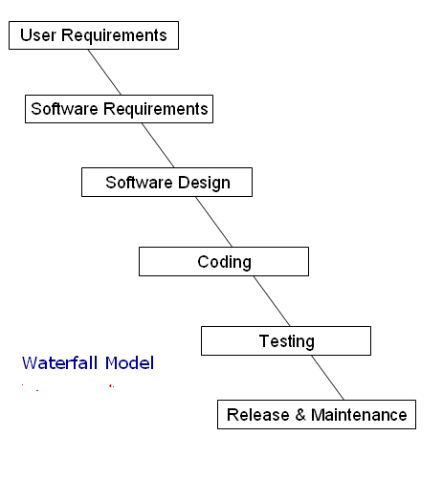

Waterfall Model Diagram

**c) Design:**  
   
In this phase Global and Detailed design can be produced based on Software Requirements.

**d) Coding:**

This step consists of actually constructing the product as per the design specification(s) developed in the previous step. Typically, this step is performed by a development team consisting of programmers, interface designers and other specialists, using tools such as compilers, debuggers, interpreters and media editors. The output of this step is one or more product components, built according to a pre-defined coding standard and debugged, tested and integrated to satisfy the system architecture requirements. 

**e) Testing:**

In this stage, System will be tested by testers, if the find any mismatch they report defects. Developers /Programmers fix the defects and then testers close defects by performing confirmation testing (Regression Testing).   
  
**f) Release & Maintenance:**

Release team (consists of a few developers, testers, and tech-support people etc…) install software in Customer environment and they consider below factors;  
  
Correct & Complete installation  
  
User Management  
  
Services Management  
  
Coexistence with other software  
  
Handling of Input & Output devices  
  
Handling of secondary storage devices  
  
Etc…  
  
Maintenance team process Customer issues based on service agreements.  
  
**3 Types of Software maintenance:**  
  
a) Modifications  
  
b) Migration  
  
c) Retirement  
  
**Advantages of Waterfall Model :**  
i) Simple and easy to use  
  
ii) Easy to manage due to the rigidity of the model- each phase has specific deliverables and a review process.  
  
iii) Phases are processed and completed one at a time.  
iv) Works well for smaller projects where requirements are very well understood.  
  
**Disadvantages of Waterfall Model :**  
  
i) No working software is produced until late during the life cycle  
  
ii) High amount of risk and uncertainty   
  
iii) Poor model for complex and object oriented projects.  
  
iv) Poor model for Long and ongoing projects  
  
v) Poor Model where requirements are at a moderate to high risk of changing.

**V Model**

**Overview:**

A framework to describe the software development life cycle activities from requirements specification to maintenance. 

The V-model illustrates how testing activities can be integrated into each phase of the software development life cycle. 

V Model was inaugurated in order to avoid drawbacks in Waterfall model and its main focus on multiple stages of testing.

Multiple stages of Testing avoids defects multiplication.

**Software Quality:**

**Quality:**Meeting Customer Requirements and expectations.

**Software Quality:**   
  
Meet Customer Requirements (Functionality)  
Meet Customer Expectations (Performance, Usability, portability etc...)  
Cost to purchase license  
Time to release  
  
***Note: First two factors are Technical, last two factors are Non-Technical.***

**Quality Assurance (QA):**  
  
Defining, Monitoring and Optimizing the process is called Quality Assurance, it is part of Quality Management and It is Prevention oriented.

**Quality Control (QC)**  
  
Checking the System (Final Outcome) with respect to Requirements is called Quality Control and it is Detection oriented.

**Verification:**  
  
Testing Quality work products (Documentation such as Test Plan, Test Cases Etc...) by performing Reviews and conducting meeting etc... and it is Static

**Validation**  
  
Testing the Working Software based on its Requirements and it is Dynamic.

**Verification                                    Validation**

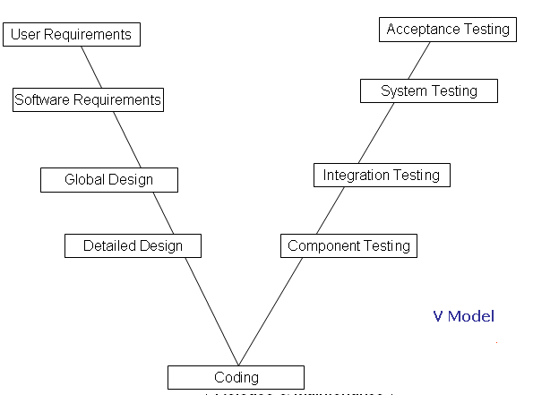

**Description of V Model:**  
  
It is Verification & Validation model, known as V Model, in this model all development phases can be integrated with Testing phases.  
  
It is considered to be an extension of the Waterfall model. This is because just like the waterfall model, it's a well structured method in which the different phases progress in a sequential or linear way. That means each phase begins only after the completion of the previous phase.   
  
**Development Phases Integration with Testing Phases**  
  
**a) User Requirements Vs Acceptance Testing**  
  
Business Analyst category people gather requirements and the document the requirements, after documentation Reviews, Meetings like verifications will take place in order get correct & Complete Requirements.     
  
End Uses derive Acceptance Test cases from User Requirements.  
  
  
**b) Software Requirements Vs System Testing**  
  
Development Manager/Tech Manager converts User Requirements as Software Requirements and Reviews, Meetings like verification methods will be performed on Software Requirements, after Verification Project manager provides Approval.  
Independent testers generate test cases from Software Requirements in order to perform System Testing    
  
**c) Global Design Vs Integration Testing**  
  
System Architect / senior developer creates Global design, Informal Review/ Walk through / Technical Review / Inspection like Verification methods will be applied on Design documents.  
Developers perform Integration Testing based on Software Global Design**.**  
  
**d) Detailed Design Vs Unit / Component Testing**  
  
Developers perform Unit /Component Testing  based on Software Detailed Design**.**

**Advantages of V Model:**  
  
o    Tester role will take place in the requirement phase it self  
o    Multiple stages of Testing available so that Defects multiplication can be reduced.   
o    Can be used for any type of requirements  
o    Due to Multiple stages of Testing and Multiple teams involvement Quality can be improved.  
o   The V Model Supports wide range of development methodologies such as Structured and Object oriented systems development.  
o   The V Model supports tailoring.

**Disadvantages of V Model:**  
  
o  It an expensive model than Waterfall model, needs lot of resources, budget and time.  
o  Co-ordination and Maintenance are difficult.  
o  Adoption of changes in Requirements and Adding New Requirements at middle of the process are difficult.  
o  It needs an established process for proper implementation.